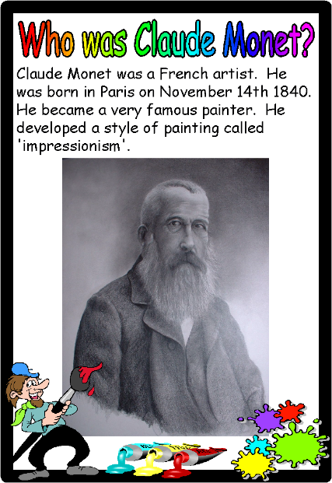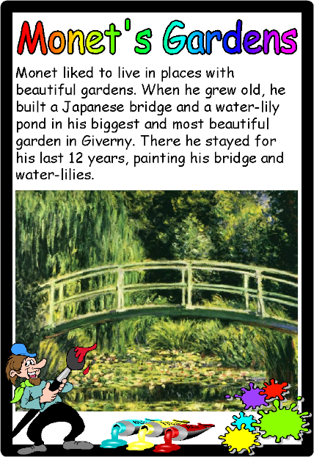
Video about Claude Monet: http://www.viewpure.com/7iEGeuVeUEg?start=0&end=0
Materials:
Thick Paper
Finger Paint
Painters Tape or Masking Tape
Instructions:
- Use tape to form the shape of the bridge shape across your page, similar to the bridge in the picture above. (Cut your tape in half for thinner strips).
- Finger paint! Let your child explore with the different colours. Show them how to dab their finger multiple times to start filling the whole page with color.
- Allow the painting to dry before peeling off the tape.

