DIY Kinetic Sand
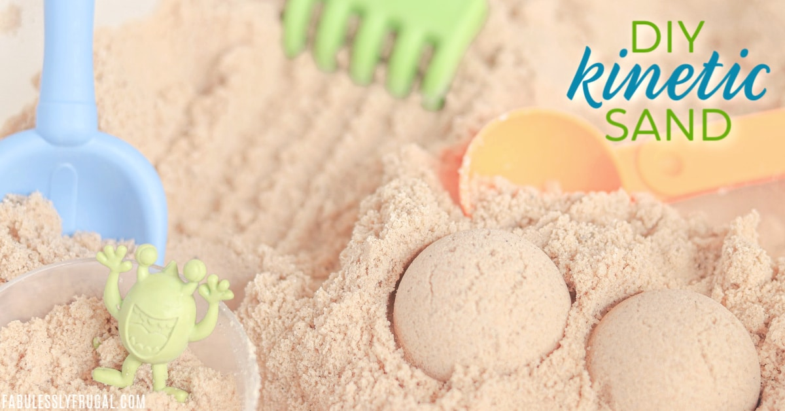

Ingredients
1 cup of fine/play sand
½ tablespoon of cornstarch
1tsp dish soap
1 cup of water (add more as needed)
Directions
Mix sand and cornstarch. In a different container, mix water and dish soap. Stir until bubbly. Add soap mixture to sand mixture as needed. Mix until desired consistency.

