Monet-Inspired Lily Pads
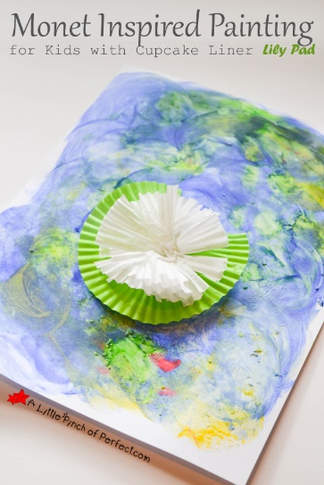
Materials
Blue and green finger paint
Paper
Cupcake liners
Instructions
Use the blue and green finger paint to cover the whole piece of paper. What happens when you mix blue and green together? Explore with different texture. What does it look like when you dab your finger on the page? How about when you run your finger across the page?
When you are done exploring with the finger paints, set it aside to dry. Take one cupcake liner (green) and cut out a triangle shape from the center so that it looks like a lily pad. Glue the green lily pad cupcake liner to your paper (add more than one if you like!). Next, cut some white or pink cupcake holders from the outside towards the center. Do this all around the whole cupcake liner so that it looks like you have a flower shape with petals. Scrunch them up a tiny bit and glue them into the centers of your green lily pads.
Your lily pad art is complete!

